Order Of Lenten Service

Opening Hymn: TLH 143 vs 1-5

Reading: Lent VI

The History of the Passion of our Lord

Sermon Hymn: TLH 143 vs 6-10

Sermon Text: Luke 20:45-47

The Scribes

Confession of Sins: O almighty God, merciful Father, I, a poor miserable sinner, confess unto Thee all my sins and iniquities, with which I have ever offended Thee and justly deserved Thy temporal and eternal punishment. But I am heartily sorry for them and sincerely repent of them, and I pray Thee of Thy boundless mercy and for the sake of the holy, innocent, bitter sufferings and death of Thy beloved Son, Jesus Christ, to be gracious and merciful to me, a poor, sinful being.

Holy Communion

The Lord's Prayer

The Blessing

Closing Hymn: TLH 143 vs 11-15

* * * * * * * * * * * * *

Bible Study: Lambs: TBA
Sheep: Deuteronomy 2:1-15
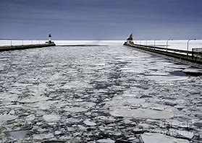

Spring In Duluth, MN

Water
Of
Life

26 March 2023

W A T E R O F L I F E

Independent Christian Church—Conservative Lutheran Doctrine

Worship Service: 9:30 a.m. Bible Study: 10:45 a.m.

Larry Cooper, Pastor E-Mail address:
lcooper@wateroflife.cc
Web Site:
www.wateroflife.cc

* * * * * * * * * * * * * * * * * * * * * * * * * * *

Sermon Text: Luke 20:45-47

The Scribes

* * * * * * * * * * * * * * * * * * * * * * * * * * *

45 Then in the audience of all the people he said unto his disciples,
46 Beware of the scribes, which desire to walk in long robes, and love greetings in the markets, and the highest seats in the synagogues, and the chief rooms at feasts;
47 Which devour widows' houses, and for a shew make long prayers: the same shall receive greater damnation.

